myClark ctcLink
Efficient, Simple, Solid

Reporting Time

Reporting the number of hours you worked is done in Employee Self Service. The easiest way to get here is through the left sidebar link in the ctcLink Gateway.

Use the **time** tile.

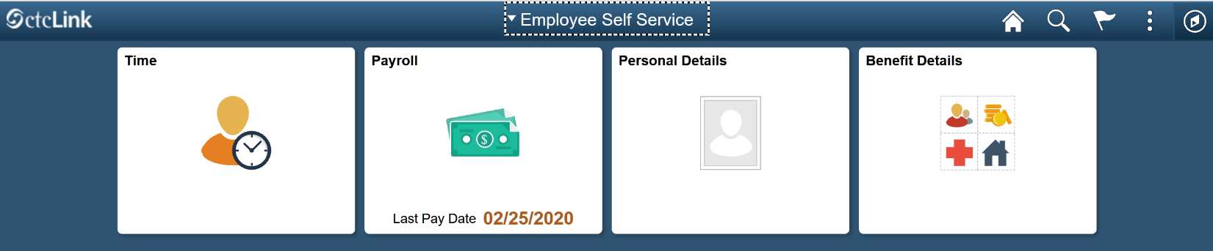

You now have two options. You can **enter** time, or **report** time.

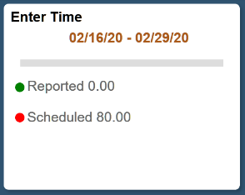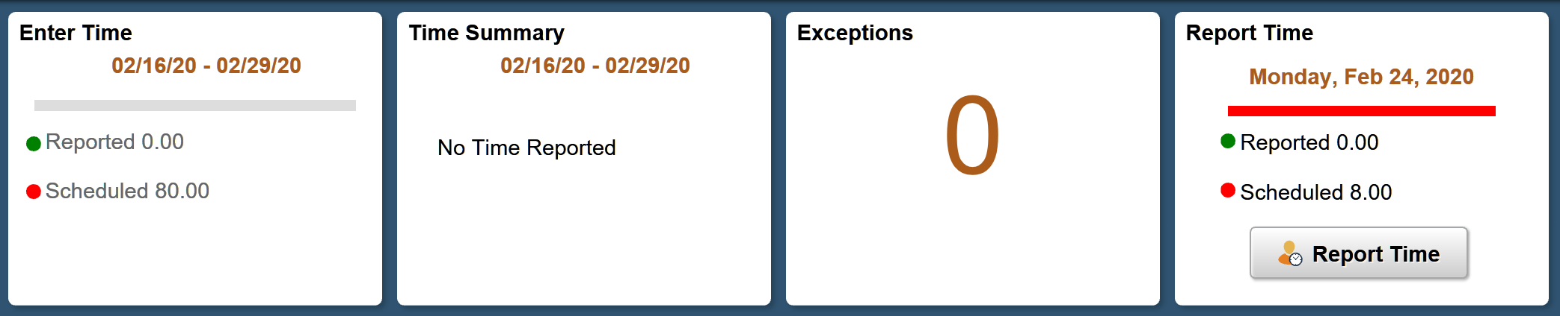

Note the Enter Time tile shows the full time-period, with a summary of the number of hours reported and the number of hours scheduled.

This is where you can go to add multiple days at one time.

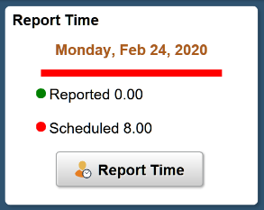Note the Report Time tile only shows today’s date, with the number of hours scheduled today and the number of hours reported.

This is where you go to report one day at a time. You can enter more than the current day using this tile.

This is the tile recommended for anyone using assistive technology. This is also to only time available if you are using ctcLink on a mobile device.

# Report Time

This is the only tile available if you are using ctcLink on a mobile device. This is also the recommended way to enter time using assistive technology, whether you are using a mobile device or desktop.

The date appears at the top. Use the arrows to the left and right of the date to go back or forward a day and enter time.

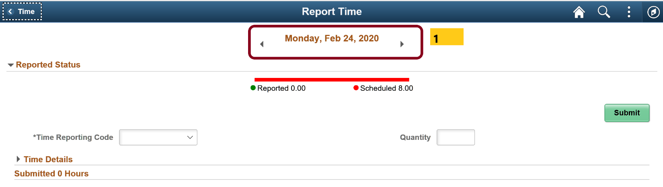

1. Select an option from the Time Reporting Code drop down menu. If you have not requested and absence and been approved by your supervisor then there will not be a reporting code available for you to report sick-leave or vacation, etc.

2. Enter the number of hours for that particular Time Reporting Code. Most of the time you are reporting one code and your full hours. Sometimes you may be reporting 01 Regular hours worked in addition to sick time or some other absence. You will see the total hours submitted for the day in the section number 4, after you are done.

3. Submit and 4. View your submitted hours.

Use the arrows next to the date if you want to report another day.

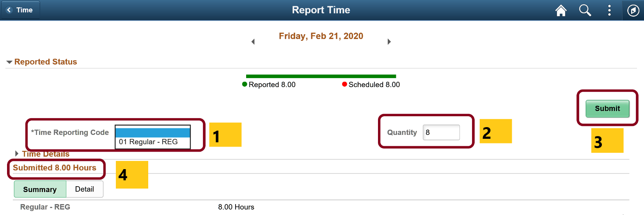

Note: each day you enter time your supervisor will be notified and can go and approve time.

# Enter Time

If you wait until the end of the time period to enter all your time you can use the Enter Time tile. The top section (1) displays a full time-period, with arrows to change to a different time-period. However, you are only able to see one week at a time (2) displayed as Week 2 of 3.

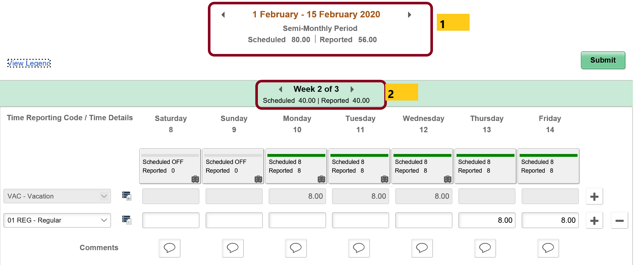

Approved vacation time is automatically filled in. Use the + to add a row for regular time.

The Enter Time tile also allows you to enter comments.

When you use the Enter Time tile you are entering all your time for the time period and submitting. If you add time but do not submit you will see this error:

You have unsaved Data on this page. Select OK to go back and save, Cancel to continue.

However, there is no option to save and return later. You would need to Submit your information, which them submits your time for the entire period even though you have not entered all your time.

If you are a time reported your supervisor may ask you to use the Report Time tile and report your time daily. If you are a salaried employee you do not report your hours worked. You only need to report the leave time you used (after you have requested and been approved).